Covid Death Rates, 1st and 2nd Differences

Brandon Tao

10/12/2020

### 0. Setup

library(tidyverse)  
library(micromapST)  
load('Data/Covid_Rates_Two_Week_Gaps.RData')  
objects()

## [1] "caseRates3" "deathRates3" "st_caseRates3" "st_deathRates3"

### 1. Arrow plots

Providing the labeling to describe a plot’s content in constrained spaced often poses a challenge. Shorter labels can take up less space and simplify appearance. Here the units of measure label, ‘Cases per 100,000’ is clear but long. Below the label is shortened to ‘Cases per 100K’.

The grid line labels can also take up space. In this example The units are thousands so 4 digits long. Rescaling the units to percents is thinkable. Then there would be only one digit each.

Scaling Choices can be guided by the target audience. Those in the health sciences are likely to think in terms of rates such as rate per 100,000 or rate per million. In criminology rates per 1000, and 10,000 are likely more common. Much of public is more familiar with percents.

The general strategy is have two or maybe three digits to the left of the decimal place. This can motivate taking logs. Graphics and and modeling can also call for taking logs.

Note that micromapST has some options in terms of gridline algorithms and the alternating rows of gridline labels avoid overplotting.

dat <- as.data.frame(st_deathRates3)  
names(dat)

## [1] "Postal" "Sep_11_2020" "Sep_25_2020" "Oct_09_2020"   
## [5] "Name" "Fips" "Pop" "Sep_11_2020_R"  
## [9] "Sep_25_2020_R" "Oct_09_2020_R"

panelDesc1 <- data.frame(  
 type = c('maptail','id','arrow','arrow','arrow'),  
 lab1 = c('','','Sept. 11 and','Sept. 25 and','Sept. 11 and'),  
 lab2 = c('','','Sept. 25','Oct. 9','Oct. 9 '),  
 lab3 = c('','','Deaths per 100K','Deaths per 100K','Deaths per 100k'),  
 col1 = c(NA,NA,'Sep_11_2020_R','Sep_25_2020_R','Sep_11_2020_R'),   
 col2 = c(NA,NA,'Sep_25_2020_R','Oct_09_2020_R','Oct_09_2020_R')   
)  
  
  
micromapST(dat, panelDesc1,  
 rowNamesCol = 'Postal',  
 rowNames = 'ab',  
 sortVar = 'Sep_11_2020_R', ascend = TRUE,  
 title = c("Covid-19: Two-Week Death Rate Changes",  
 "Fridays: Sept. 11 to Oct. 9, 2020 ")  
)

## End of micromapST processing.

## No warnings were logged.

## No stop messages were logged.

##

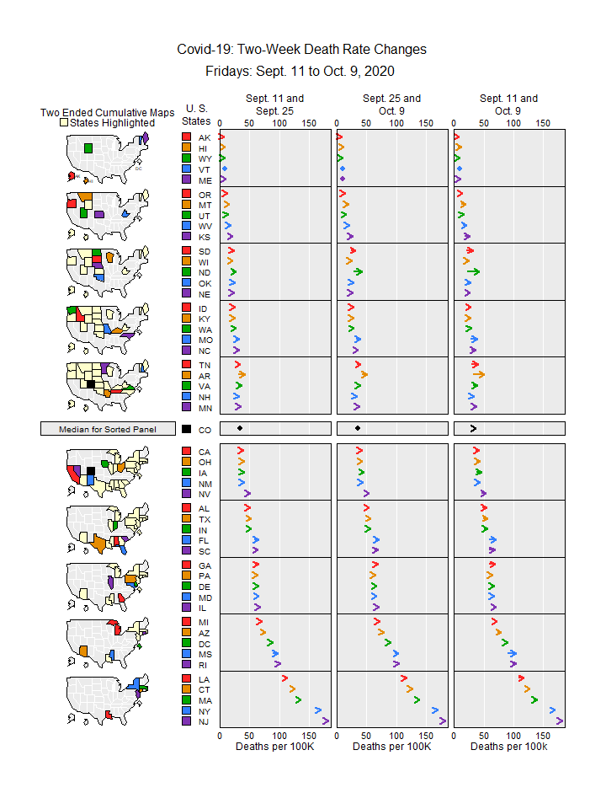

## [1] "micromapST Ends"

### 2. Compute First and Second Differences

For time series, second differences provide discrete analogues to the second derivatives in continuous time series. Trends usually do vary over time. With Covid-19 many variables drive the change in the trends. We don’t know them all, and often don’t have data on the variables that we conjecture. Here we look at just one second difference.

names(st_deathRates3)

## [1] "Postal" "Sep_11_2020" "Sep_25_2020" "Oct_09_2020"   
## [5] "Name" "Fips" "Pop" "Sep_11_2020_R"  
## [9] "Sep_25_2020_R" "Oct_09_2020_R"

tib <- select(st_deathRates3,Postal,Sep_11_2020_R:Oct_09_2020_R)  
names(tib)<- c('Postal','Fri1','Fri2','Fri3')  
tibDif <- mutate(tib,  
 dif1=Fri2-Fri1,  
 dif2=Fri3-Fri2,  
 dif3=dif2-dif1)

### 3. Show the differences using micromapST

dat <- as.data.frame(tibDif)  
names(dat)

## [1] "Postal" "Fri1" "Fri2" "Fri3" "dif1" "dif2" "dif3"

panelDesc2 <- data.frame(  
 type = c('maptail','id','dot','dot','dot'),  
 lab1 = c('','','Sept. 25 -','Oct. 9 -','Change in'),  
 lab2 = c('','','Sept. 11','Sept. 25','Differences'),  
 lab3 = c('','','Deaths per 100K','Deaths per 100K','Deaths per 100k'),  
 col1 = c(NA,NA,'dif1','dif2','dif3')  
)  
  
  
micromapST(dat, panelDesc2,  
 rowNamesCol = 'Postal', # Use this column  
 rowNames = 'ab', # Names are State Postal codes   
 sortVar = 'dif3', ascend = TRUE,  
 title = c("First and Second Death Rate Differences",  
 "Fridays: Sept. 11 to Oct. 9, 2020 ")  
)

## End of micromapST processing.

## No warnings were logged.

## No stop messages were logged.

##

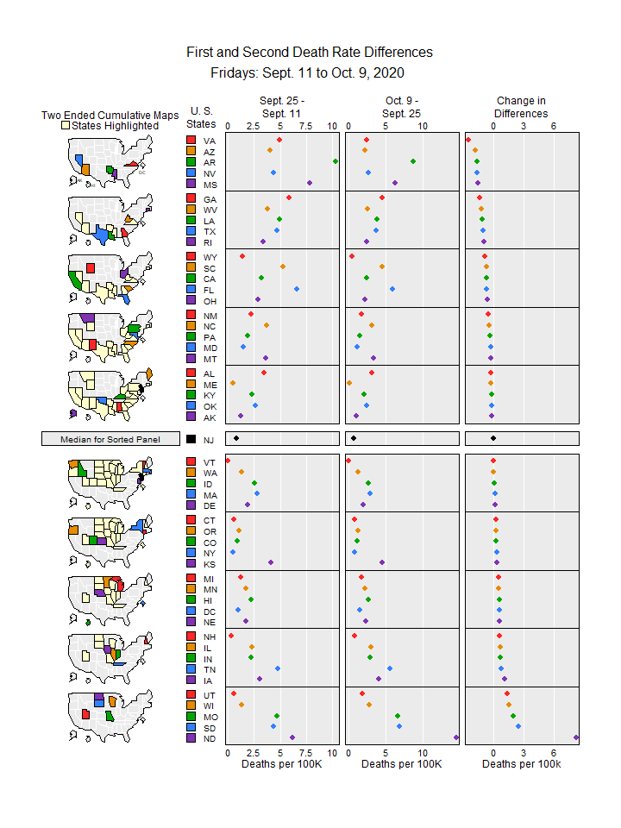

## [1] "micromapST Ends"